
Handling Spatial Location Data
Introduction
This document gives guidelines for handling the quality control, transmission, conversion, and obfuscation of co-ordinate data.
One goal is to keep this simple – references will need to be added to point the reader towards further information (references worthwhile, but it’s a slow process - BK).
Fundamentals
Spatial co-ordinate data (aka geocodes) are used to anchor other data to a point in space. Generally speaking, there are two accepted ways this information can be presented.
- latitude and longitude – measure of angular rotation about a centre from a base-line
- eastings and northings – measure (in metres) associated with the base-line of a grid projection

In each case ‘the centre of what?’ or ‘associated with what?’ relates to the datum. The datum is the precise placement of a latitud- and longitudinal grid. This placement is likely to be based on a mathematical model (or a best-fit representation) of the shape of the earth known as the ellipsoid. This ellipsoid is a simplified (for calculations) representation of the surface of the earth based on the best observation data at a particular point in time. Datums (plural) evolve over time as measuring capabilities get more accurate.
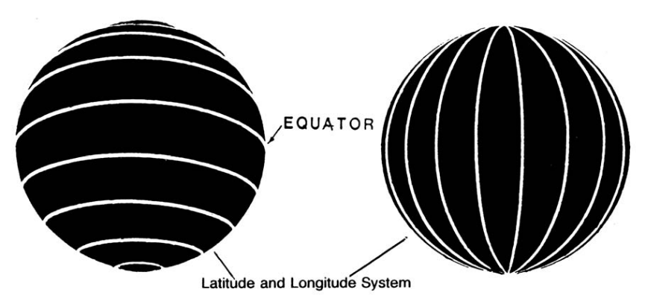  Lines of latitude (parallels) and longitude (meridians) | Lines of latitude (running EW) and longitude (running NS) are reference points associated with a particular datum.  Lines of latitude, or parallels, (hint – ‘laddertood’) are spaced evenly along the major axis of earth’s rotation, where as longitude, or meridians, divide the earth up into equal measures of rotation, 6° (six-degrees) wide.
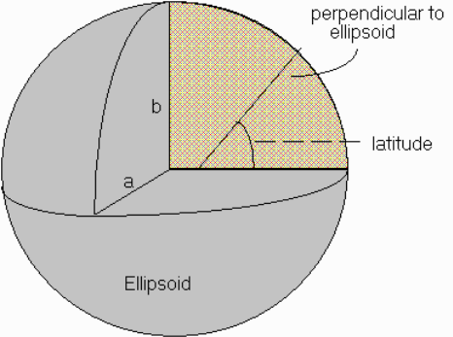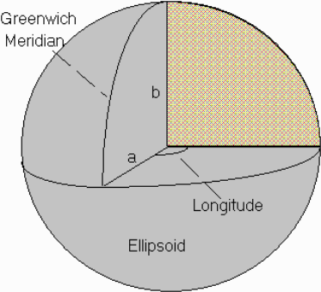  Angles of latitude and longitude | Both allow a measure of angular rotation to be made.  These measures are shown as degrees° minutes’ seconds” (DMS), where one degree is 1/360th of rotation, one arc-minute is 1/60th of a degree and one arc-second is 1/60th of a minute.  They can also be represented in decimal degrees (DD), where DD = D + (1/60 x M) + (1/3600 x S)

Fundamentals continued…

Eastings (NS, x) and northings (EW, y) measure (in metres) to or from a base-line associated with a grid projection; there are many ways to do this.  One common form of grid involves projecting the ellipsoid onto a cylinder, using the method called the Universal Transverse Mercator (UTM).  A full UTM projection consists of 60 separate strips (zones), each 6° (six degrees) wide, numbered from 1 to 60, centred on a datum’s line of longitude. | 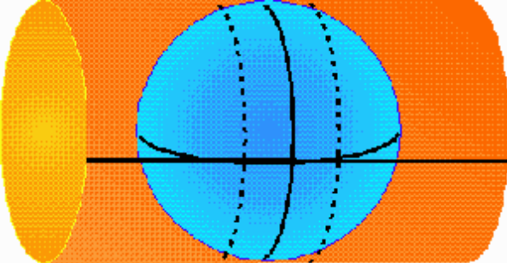  A UTM projection of one zone
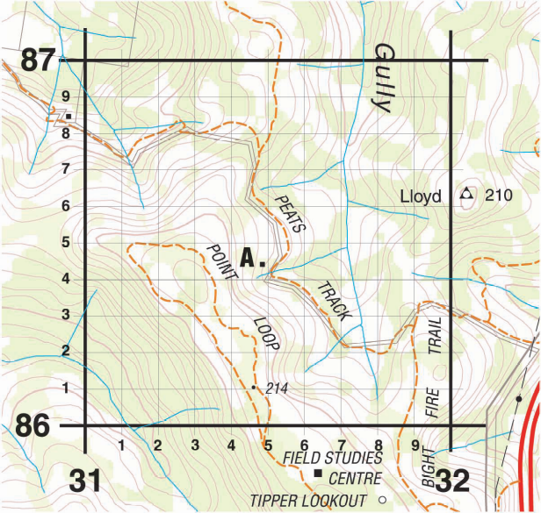  A grid square from an unknown zone & datum – without these, exact location can’t be determined | This centre-line of each zone is called the central meridian. It is given an arbitrary figure of 500,000 metres, and referred to as the false easting.  Each zone is divided into 8° of latitude, and given a suffix between A and Z (O and I unused). The longitudinal zone number + the latitudinal zone suffix are combined to define a grid cell.  Grid cells are divided up by lines spaced 1km apart. The lines running NS are called eastings and the lines running EW are called northings.  An example of one grid-square (1km²) is shown; eastings (NS lines 31, 32) and northings (EW lines 86, 87) are then divided into 10th’s (each 100m wide) and used to determine a grid reference.  The top of a map showing grid coord’s points to grid north. This measure of north has a relationship with magnetic north, which varies in space and time.

The datum and method of representation determines what each measurement relates to (the base-lines).
 | Latitude | Longitude | Easting (UTM) | Northing (UTM)
base-line | the equator, 0° | prime meridian, 0° | false easting, 500,000 | equator – 0 or 10,000,000 (NH or SH)
think | angular rotation from the equator, N+/S- from 0° to 90° | angular rotation from the prime meridian, E+/W- from 0° to 180° | metres along the easting (false easting – easting = distance to the central meridian) | in the northern hemisphere: 0 + x metres from the equator; in the southern: (the false northing – northing = distance to the equator)

Transmission
Below are three ways of giving the same location. The first two are examples of latitude & longitude (geodetic or geographic co-ordinates), the latter are examples of easting & northing (grid coordinates) -
degrees° minutes’ seconds” | -34° 33’ 43.04645” | 150° 38’ 20.75338” | WGS84
decimal degrees | -34.56195734722222 | 150.6390981611111 | WGS84
grid coordinates | E 283400.000 | N 6173000.000 | MGA94 Zone 56
6-figure grid reference | 834730 |  | MGA94 Zone 56
(Near the Illawarra Hwy, escarp. above Macquarie Pass) The grid coord’s were converted from lat/long to MGA94 using Redfearn’s formulae. Measurements & conversions were performed on 2nd August 2010.
For an example of the 6-fig. grid-ref., see the earlier grid square image in this document – note point A with coord’s 315x, 865y (written 315865) which translates as E ?31500 (eastings) N ??86500 (northings).
Note the placeholders (?) at the more significant digits in the various offsets? This is a good example of incomplete information – there is no zone or datum, so the continental-scale info. can not be provided.
Ellipsoids, Datums and their associated Grid Projections
 | Acronym | What? | Description
current | GDA94 | Datum | Geocentric Datum of Australia – the current datum based on GRS80, compatible with WGS84 and the GPS network
current | MGA94 | UTM projection | The UTM grid projection based on the GDA94 datum
current | WGS84 | Datum | The World Geodetic System – datum based on GRS80, modified slightly to form the basis of the GPS (Global Positioning System) network
current | GRS80 | Ellipsoid | Geodetic Reference System – the current ‘best-fit representation’ (ellipsoid) of the earth, which corresponds with earth’s centre of mass
historical | WGS72 | Datum | The World Geodetic System – earlier basis of the GPS network
historical | AGD84, AGD66 | Datum | The Australian Geodetic Datum – datum based on a statistical correction of the ANS
historical | AMG84, AMG66 | UTM projection | The Australian Map Grid – grid projections based on their respective AGDxx datums
historical | ANS | Ellipsoid | The Australian National Spheroid – an ellipsoid representing the earth as it best fit to the Aus. Continent (as opposed to the centre of mass of the earth) – a corrected version of this was used to generate the AGD
A table of likely acronyms, their classification, and description
Quality
There are many sources of error in the gathering and transmission of geospatial coordinates. To start with, there may be accuracy errors which could be introduced by the GPS in use, by the skill of the map & compass reader, by the method of (or omissions in) recording or transcribing data from field-notes to digital record, …
If you don’t know what datum was in use when the measurement was taken, then this is one of the sources of uncertainty in the data. Conversely, if you do know what datum was in use and it was one that didn’t exist when the observation was made, then a conversion has taken place; here is another source of uncertainty – the method used to make this conversion must be determined.
The examples in the Transmission section above demonstrate a complete set of information to reliably transmit the spatial location information. Note: measurements, date-stamp, method, descriptive text.
Conversion
Discussion about grid (projection) coord’s and different methods of conversion between datums:
- ie from grid projection to lat/long before moving between datums
- grid shift if algorithm & dataset is available
Pointer to ala geospatial doco. Pointer to GEOTRANS user manual.
There are two types of conversion with spatial data – conversion between lat/long coord’s and grid coord’s, and conversion between datums. For the purposes of discussion I present some information that can be used to perform mental calculations. For more information on the maths & algorithms behind these, see: https://sites.google.com/site/atlaslivingoz/ala-data/geospatial-conversions
Measure | Degrees | Decimal degrees | Metres (lat/long)  (roughly, equator) | Metres (lat)  (roughly, poles) | Metres (long)  (roughly, poles)
1° | One | 1.00 ° | 111,000 | 111,000 | 85,000
1’ (arcmin) | 1/60 ° | 0.01666… ° | 1,700 | 1,700 | 1,300
1” (arcsec) | 1/3600 ° | 0.00002777… ° | 30 | 30 | 22
0.01° | 1/100 ° | 0.01 ° | 1,000 | 1,000 | 760
0.001° | 1/1000 ° | 0.001 ° | 100 | 100 | 76
Comparison between the different types of measurement – something to note: degrees of latitude are parallel so the distance between each degree remains almost constant, but since degrees of longitude are farthest apart at the equator and converge at the poles, their distance varies greatly.

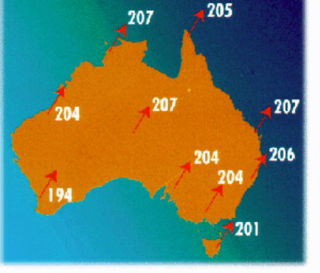
For conversion between the three most common datums in present-day Australian use (from AGD66 / AMG84 to MGA94) a shift of roughly 200m to the northeast is an easy mental calculation that is based on the high-accuracy grid shift method.
To achieve this, you can add roughly 140m to both the x & y grid coord’s (a² + b² = c²). For DMS & DD: 5” or 0.0015 ° to your respective latitudes (NS); longitude (EW) will require more thought, decreasing as you get closer to the poles.

Examples of ALA Data
Obfuscation

Geoscience Australia > Earth Monitoring > Geodesy and GPS > Geodetic Infrastructure - Datums http://www.ga.gov.au/geodesy/datums/aboutdatums.jsp#Mathematical%20Figures%20of%20the%20Earth
Wikipedia > Figure of the earth > http://en.wikipedia.org/wiki/Figure_of_the_Earth
Latitude, Longitude System and Marine Charts – EMA Manual 36 (Map reading and navigation) – chapter 11, section 11.10 page 67; http://www.ema.gov.au/ > Publications > AustralianEmergencyManualSeries
Intergovernmental Committee on Survey and Mapping – GDA Technical Manual version 2.3a1 (Feb. 2006) – Chapter 12 glossary, glossary diagrams page 54; http://www.icsm.gov.au/icsm/gda/gdatm/index.html
ICSM > Fundamentals of mapping > Commonly used map projections > http://www.icsm.gov.au/mapping/map_projections.html#grid_amg
Wikipedia > Universal Transverse Mercator coordinate system http://en.wikipedia.org/wiki/Universal_Transverse_Mercator_coordinate_system
ICSM – GDA Technical Manual version 2.3a1 (Feb. 2006) – Chapter 1 Background and explanation, Grid coordinates page 5; http://www.icsm.gov.au/icsm/gda/gdatm/index.html
Grid References – EMA Manual 36 (Map reading and navigation) – chapter 4, figure 4.2 page 13; http://www.ema.gov.au/ > Publications > AustralianEmergencyManualSeries
ICSM > Fundamentals of mapping > Marginalia Information > http://www.icsm.gov.au/icsm/mapping/marginalia.html#grids
Grid References – EMA Manual 36 (Map reading and navigation) – chapter 4, section 4.6.b page 12; http://www.ema.gov.au/ > Publications > AustralianEmergencyManualSeries
Direction – EMA Manual 36 (Map reading and navigation) – chapter 6, section 6.4 – 6.11 pp 29 – 31; http://www.ema.gov.au/ > Publications > AustralianEmergencyManualSeries
Geoscience Aus. > Earth Monitoring > Geodesy & GPS > Geodetic Infrastructure - Datums > World Geodetic System [WGS] > http://www.ga.gov.au/geodesy/datums/wgs.jsp
Deutsches Geodätisches Forschungsinstitut > DGFI Home > Geodetic Reference System 1980 > http://www.dgfi.badw.de/
Geoscience Aus. > Earth Monitoring > Geodesy & GPS > Geodetic Infrastructure - Datums > Australian Geodetic Datum [AGD] > http://www.ga.gov.au/geodesy/datums/agd.jsp
Geoscience Aus. > Earth Monitoring > Geodesy & GPS > Geodetic Infrastructure - Datums > Australian Map Grid [AMG] > http://www.ga.gov.au/geodesy/datums/amg.jsp
Geoscience Aus. > Earth Monitoring > Geodesy & GPS > Geodetic Infrastructure - Datums > History of Australian Datums > http://www.ga.gov.au/geodesy/datums/history.jsp

